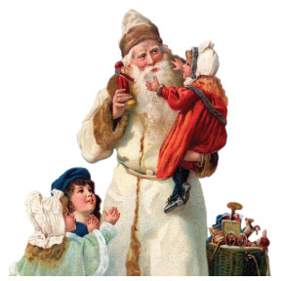
Belgium’s 2019 European Christmas Parade & Market
Saturday, December 7, 2019, 4:30 pm
Parade Registration Form
Please complete and return this form by Friday, November 22, 2019 to:
Belgium Area Chamber of Commerce
P.O. Box 215
Belgium, WI 53004
Or email to: Belgiumareachamber@gmail.com

GENERAL INFORMATION:
Your Name __________________________________________________________
Business or Organization Name__________________________________________
Address_____________________________________________________________
City________________________________________State______ Zip___________
Cell Phone #_______________________Email______________________________

_____YES, I/We would like to participate in the Belgium Christmas Parade on Saturday, December 7, 2019. I/We will participate in the following ways- Mark All that Apply.

______ I/We would like to make a monetary donation in the amount of $ ______
to help support the parade (please make check payable to the BACC)

______Float- Brief Description:__________________________________________

______Band or Marching Unit- Number of Participants:______________________

______ Walking Unit- Number of Participants:______________________________
Brief Description:_______________________________________________

______Fire Trucks- Number of Trucks:____________________________________

______Other Automobiles/Trucks/Machinery- Number of Vehicles:____________

______ Other- Please specify:___________________________________________

______ There will be music with my/our entry- Live or Recorded?______________

______ There will be animals with my/our entry- How many?__________________
(Please arrange for immediate animal clean-up on the route as a courtesy to other participants.)

______ NO, I/We are unable to participate this year.

THANK YOU FOR YOUR SUPPORT AND PARTICIPATION!!

